DocEP – Request for Assistance

|  |
| --- |
| This form is designed to help you introduce a request for support in case of problems with the installation or use of the DocEP macro.  All fields have to be filled in. Incomplete requests will be rejected. |

# Instructions

Prior to filling in a request for assistance, please ensure that you have exhausted all possible options in trying to address the problem. All known problems experienced by contractors have been summarised together with their solutions in the document ‘**DocEP FrequentProblems’**.

Once you have filled in this request for assistance, please send it by email to:

[**dgtrad.etucontractsexecution@europarl.europa.eu**](mailto:dgtrad.etucontractsexecution@europarl.europa.eu)

# Prerequisites

I have checked my problem against the list of known problems in the document ‘**DocEP FrequentProblems**’

I made sure that I am running the installation with **administrator privileges**

To verify your administrator status:

Go to Settings > Accounts > Your Info

It should read ‘**Administrator’** under your name.

My computer is fully up-to-date (all OS+MSOffice updates have been installed), and my computer is virus-free and freshly rebooted.

To verify your computer installation status:

Go to Settings > Update & security > Windows Update > Check for updates;

The Update status should read ‘**No updates available’** or ‘**Your device is up to date’**.

Please **send us a screenshot** which states you are an administrator, as in the screenshot below:

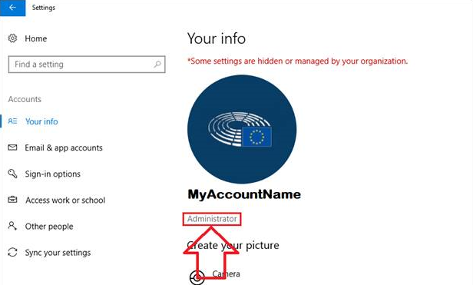

Please **send us a screenshot** with the update status of your PC, it should look similar to the screenshot below:

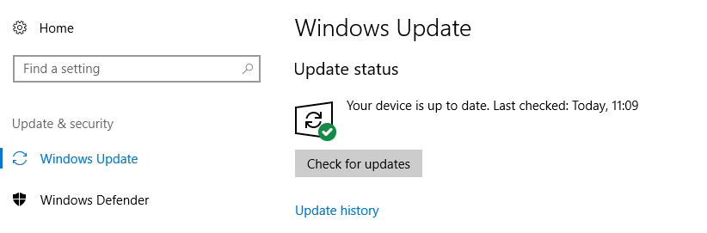

# Operating system

|  |  |
| --- | --- |
| **Operating System** |  |
| **Version** |  |
| **Language** |  |

# MS Office / Word version

|  |  |
| --- | --- |
| **Version** |  |
| **Language** |  |

Please **send us a screenshot** indicating the version of MS Word. You can find it in File> Account > About Word. It should look similar to the screenshot below:

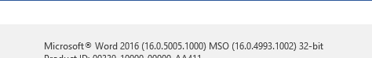

# DocEP version

|  |  |
| --- | --- |
| **Version** (see DocEP – About) |  |
| **Registry build** (see DocEP – About |  |
| **Standard installation?** (if not, specify which changes have been made) |  |

# Error description

|  |  |
| --- | --- |
| DOES THE PROBLEM OCCUR ... | |
| **On a single PC?** |  |
| **On several PCs?** |  |
| **On all PCs?** |  |
| **Other** (please specify) |  |

|  |  |
| --- | --- |
| DOES THE PROBLEM OCCUR ... | |
| **At installation?** |  |
| **During use?** (please specify the function) |  |
| **Other** (please specify) |  |

|  |  |
| --- | --- |
| ERROR REPORT | |
| **Detailed description of the sequence of steps leading up to the problem** |  |

|  |  |
| --- | --- |
| ERROR REPORT | |
| **Can the problem be systematically reproduced?** |  |

# Screenshots (mandatory in case of error message)

Please include hereafter any screenshots that might help in troubleshooting the problem.