DocEP – Frequent Problems

|  |
| --- |
| This document contains a list of the problems most commonly encountered by contractors installing DocEP on computers not running the European Parliament's standard configuration.  Prior to introducing a support request, please check your problem against this list of known issues. |

|  |
| --- |
| **WARNING : MAKE SURE YOUR PC IS FULLY UPDATED AND PERFORM A FRESH REBOOT BEFORE ATTEMPTING ANY FURTHER TROUBLESHOOTING** |

An extremely common source of problems stems from out-of-date installations of Windows or MS Office.

Before attempting any further troubleshooting please ensure that your Operating System and all its components are fully up-to-date, and that your computer is freshly rebooted.

To verify the state of your computer installation:

1. Open Settings > Update & security > Windows Update > Check for updates;
2. Install all the updates until your PC is fully up-to-date;
3. Reboot your PC.

# Installation failure

Please make sure MS Word is closed when installing DocEP.

If you encounter an installation error, the cause often lies with insufficient security rights to access the Registry of your PC. Please make sure that you are running the installation with **administrator privileges**, or consult your system administrator.

To verify your administrator status (for Windows 8/10):

1. Go to Settings > Accounts > Your Info

It should read “Administrator” under your name.

Please execute the **DocEP.reg** file which is located under the installation folder of DocEP (by default, in %userprofile%\appdata\local\docep or in C:\Program Files\DocEP). Consult your system administrator if the information could not successfully be entered into the registry. If the information was successfully entered, restart MS Word from the desktop to see if the problem persists.

# DocEP ribbons are not displayed / DocEP functions are not responding

Make sure to launch MS Word from the desktop. Some templates may not load properly when MS Word is launched from within an e-mail application or browser.

There can be several reasons why the DocEP ribbons are not displayed or DocEP functions are not responding.

**1. Wrong Startup folder** – For DocEP to work, its startup macro 'DocEPInit.dotm', has to be in the Startup folder of MS Word. In case the Startup folder has been changed from the standard location, the DocEP startup macro will have to be moved to that new Startup folder.

With a standard installation, the location of the Startup folder is C:\Program Files(x86)\Microsoft Office\Office xx\Startup (xx being a number).

The current Startup folder of MS Word can be found under File - Options - Trust Center - Trusted Locations.

Close MS Word, move DocEPInit.dotm from the standard location to the current Word Startup folder and restart MS Word.

**2. Deactivated templates** – Please make sure all DocEP add-ins are active.  
See File – Options – Add-Ins – Manage: Word Add-ins – Go.

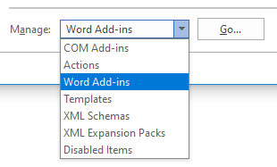

Make sure all the DocEP templates (DocEPInit.dotm, DocEP.dotm, DocEPMenu.dotm) are checked.

**3.** **Disabled templates** – Please make sure no DocEP templates are listed under Disabled Items.  
See File – Options – Add-Ins – Manage: Disabled Items – Go.

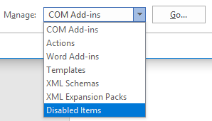

Select the disabled items and click on ‘Enable’.

**4. Insufficient macro permissions** – Please make sure ‘Enable all macros’ is selected in the Macro Settings and the option "Trust access to the VBA project object model" is checked. See File – Options – Trust Center – Trust Center Settings.

Close and restart MS Word from the desktop to see if the problem persists.